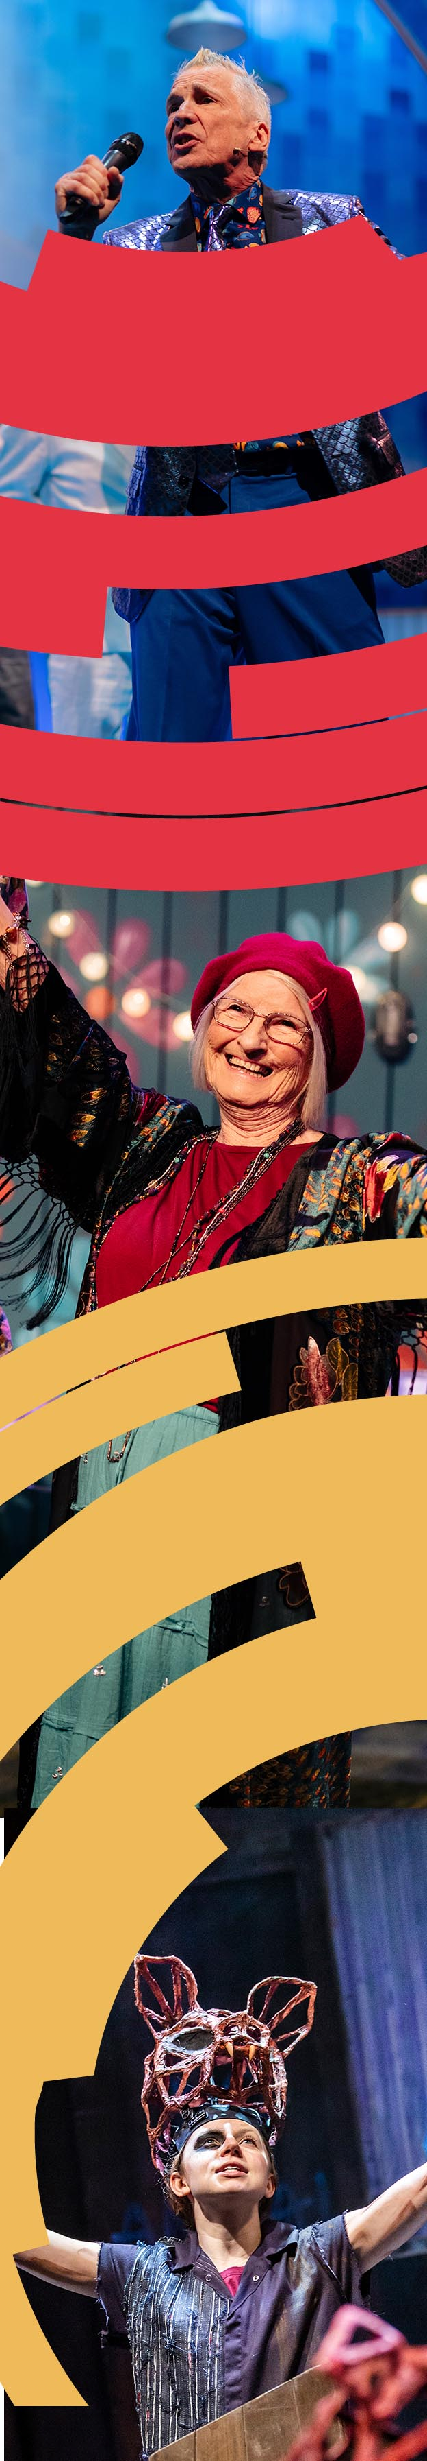
JOB DESCRIPTION

Lighting Designer – The Little Mermaid

Responsible to – Head of Production & Technical, Producer/Programmer
Contract – Fixed term until 12th December 2025.
Fee: £2000 plus subsistence as agreed.
Hours of Work – As required to fulfill design duties across dates below
Key Dates
White Card Design Meeting: Mid-August
Final Design Meeting: Early-October
Rehearsals: Monday 17th November – Friday 5th December 2025
Fit up: Thursday 4th December – Saturday 6th December 2025
Technical and Dress Rehearsals: Monday 8th December – Thursday 11th December 2025
First Performance: Thursday 11th December 2025
Final Performance: Sunday 4th January 2026
About the role
We are looking for a Lighting Designer for Hull Truck Theatre’s upcoming production of The Little Mermaid.
Join Coral and her friends on an under the sea adventure this festive season…
Coral is a friendly, fun and inquisitive little mermaid… but she’s a mermaid with a problem. Whilst she loves nothing more than nattering away with her family and closest pal Finn the fish, when it comes to talking to new people… something strange happens… she completely clams up.
But can a chance meeting with a human from the above the waves bring Coral out of her shell? Or will she fall hook, line and sinker for the sea witch’s trickery and never find her voice?
Exploring themes of friendship, courage and confidence, this heartwarming adventure is a modern-day twist on a classic story. From the team that brought you Rapunzel, Princess and the Frog and Jack, Mum and The Beanstalk, join Hull Truck Theatre for another magical festive production. Specially designed for young audiences and their families.

We are looking for a Lighting Designer to:
- Create the designs and final designs for lighting to agreed deadlines.
- Actively collaborate with the Director in the preparation of the vision of the play.
- In collaboration with the Production Manager, be responsible for ensuring the lighting design is suitable for Hull Truck Theatre.
- Work with the production team to coordinate a unified production.
- In collaboration with HTT staff, ensure the design is suitable for all access performances (eg: BSL performances, Relaxed performances).
- Attend pre-production and production meetings by mutual agreement.

About You
The successful applicant will have professional experience as a lighting designer on similar sized productions. We are particularly interested in hearing from Black and Global Majority candidates, Disabled candidates, and any candidates who are underrepresented within the theatre industry.
How to Apply
Please apply with a CV, two references, and a link to your website or portfolio.
Please send these to sarah.barton@hulltruck.co.uk.
If you’d like to apply by another format, including video, or if you are experiencing any barriers to accessing the information, then please contact our recruitment team via email at admin@hulltruck.co.uk.
The deadline for applications is 16TH MAY 2025

Hull Truck Theatre is a Disability Confident Employer.

It is widely known that people who experience barriers to employment in the Arts, due to factors such as race, gender, ethnicity, disability, or people from a working-class background, are more likely to assume that they are not the right person for a role like this. We warmly encourage you to apply.

If any of this process is inaccessible to you, please get in touch through recruitment@hulltruck.co.uk and let us know how you would like to apply e.g., by video. We will work with you to accommodate your request as best we can.

Inclusion and Equality:
At Hull Truck Theatre we want to create and sustain a productive, diverse and inclusive working environment. We ask everyone who works with us to champion this ambition and embed it in their day to day work. We actively seek and encourage applications from those under-represented within our sector and welcome opportunities to facilitate job shares and flexible working to ensure our recruitment process and workforce is as open and accessible as possible.

Environmental sustainability
We aim to be an environmentally sustainable organisation and ask that our all our teams work to support this. In doing so we are seeking to promote efficient and sustainable practices that create minimal impact.


Background Information

OUR MISSION
Hull Truck Theatre is a pioneering theatre with a unique Northern voice, locally rooted, global in outlook, inspiring artists, audiences and communities to reach their greatest potential.
OUR VISION
To produce and present inspiring theatre that reflects the diversity of a modern Britain. To provide the resources, space and support to grow people and ideas, be an ambassador for our city, a flagship for our region and a welcoming home for our communities.
OUR VALUES
We are committed to our core values of Inclusion, Innovation and Integrity.
Led by these values we are:
· Creative and Collaborative,
· Imaginative and Inspiring,
· Accessible and Relevant,
· Resilient and Sustainable.
“We tell inspiring stories dug from the heart of our city, alongside tales from the wider world, that reflect the diverse range of communities and creative voices that populate our nation. We produce exceptional drama made here in Hull, often showcasing new talent and are ambitious, bold and committed to our core values of Inclusion, Innovation and Integrity.” Mark Babych, Artistic Director
Hull Truck Theatre Company is a registered charity and consists of the theatre which produces and presents theatre in two auditoria (Stage One – 429 seats and The Godber Studio – 135 seats).
Over recent years Hull Truck Theatre has been on a journey of significant change. On stage we reach an audience of over 70,000 and continue to build on the momentum of Hull UK City of Culture 2017, when we delivered an ambitious year of exceptional drama.

Through our work with schools and local communities we engage with 14,000 young people, disabled groups and adults, offering opportunities to participate in the arts, whether as a first step into a career, a way to build confidence and meet new people, or as a part of a rounded education. Our groundbreaking Community Dialogues programme builds on long-term partnerships within Hull’s local communities to address inequalities in accessing the arts.
In response to the Covid 19 pandemic we continued to engage with our audiences, artists and communities online and invested in technology to embed high quality digital engagement opportunities in our future. We’re delighted to be welcoming audiences back to the theatre, bringing people together safely to experience live performance once more.
In 2022 we celebrated 50 years of Hull Truck Theatre. Taking a look back at the theatre’s journey since 1972 to the present, whilst also looking to the future and asking, what will the next 50 years hold? How will Hull Truck Theatre continue to inspire future generations?
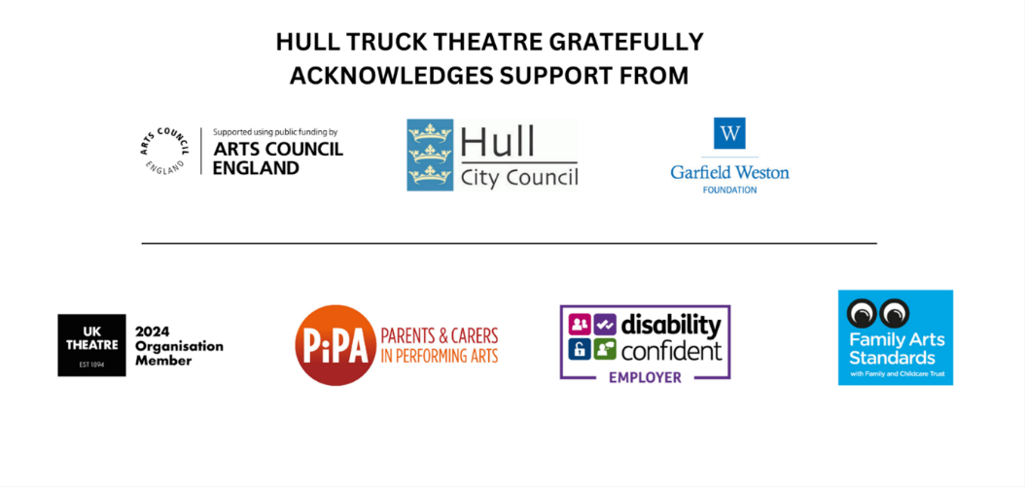
With the inspiring leadership of Mark Babych (Artistic Director) and Janthi Mills-Ward (Executive Director), the theatre is on the next stage of its exceptional journey, creating a vibrant 21st-century cultural organisation.

